PHYS 135A
Activity 2: Distance-Time, Velocity-Time Graphs

In this activity, you will be walking in front of a motion detector to produce distance-time and velocity-time graphs. You will know what it takes to produce a particular motion graph for a moving object.

You will be given Logger Pro interface and a motion detector. Dr. Zorba will describe how to do the connections. Once the connections are done, turn on the Logger Pro software program (usually on desktop). The software will recognize the detector and open the correct graph windows.

Experiment: Walk in such a way as to produce the following distance-time graphs as given on the left column below. Hand draw your obtained result on the right column for each given graph.

Goal | Experimental Result
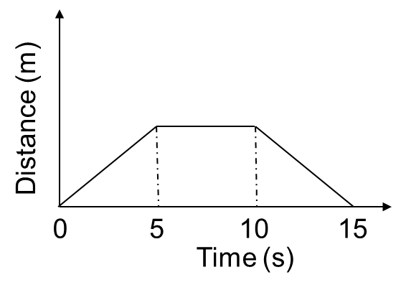 | 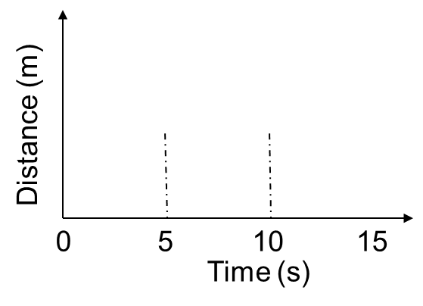
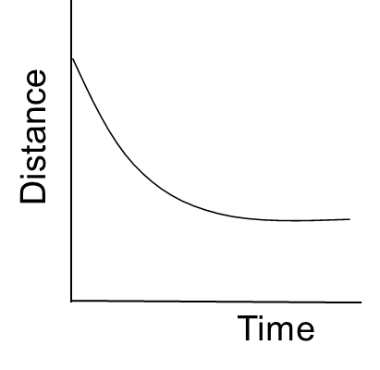 | 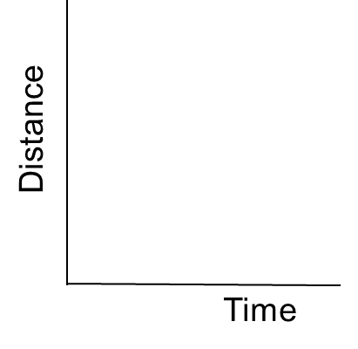
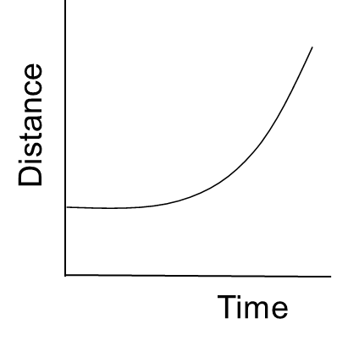
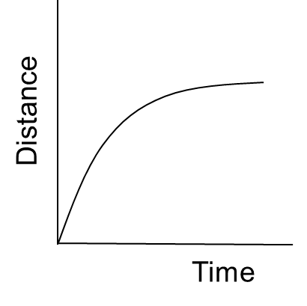
Walk so as to produce the following velocity-time graph.  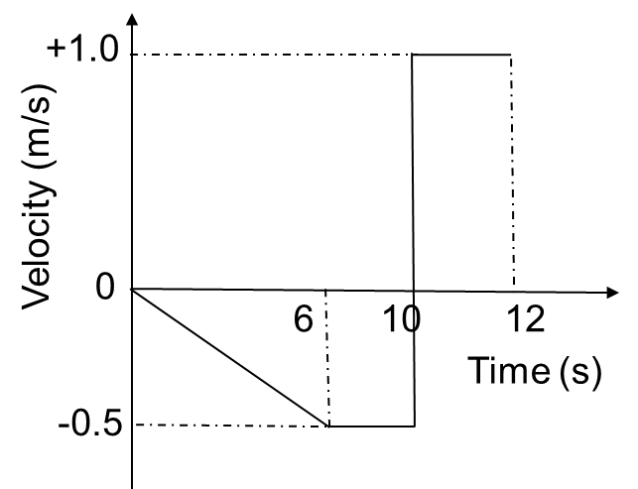 | How easy is it to create a vertical track in velocity-time graph (as in t = 10s)?  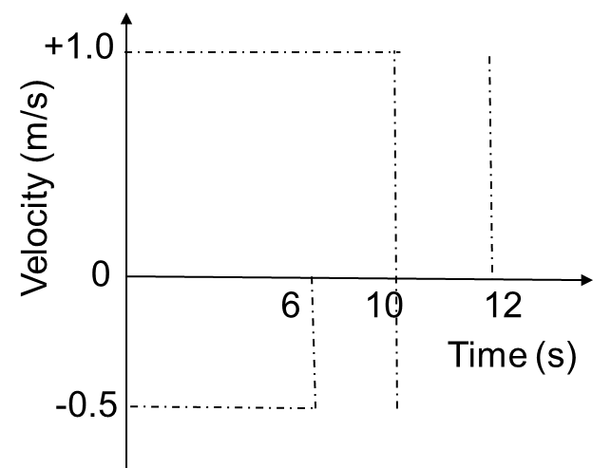
Produce the following distance-time graph. Using the graph you thus captured with Logger Pro, find the velocity for both intervals using a calculation.  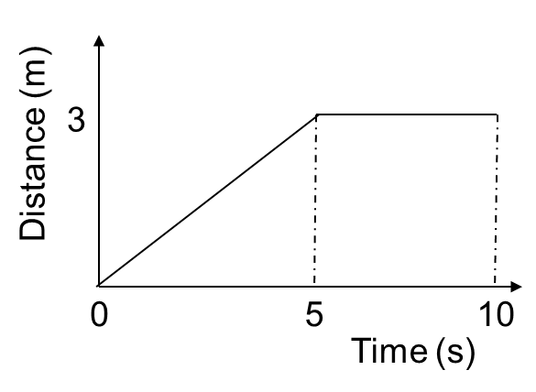 | Indicate you calculations below. Do they agree with what the Logger Pro program gives?  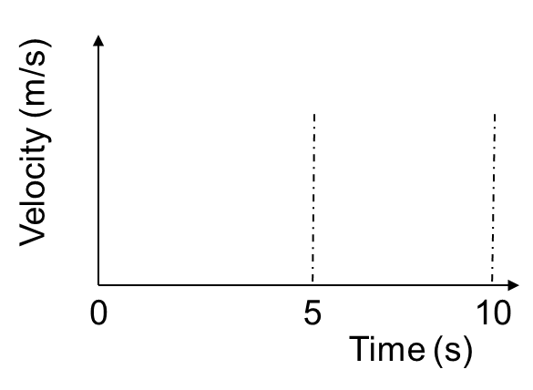

Recall:

1-) The slope in a distance-time graph is the velocity

2-) The area under the curve of a velocity-time graph is the displacement.

